SOFTWARE REQUIREMENTS SPECIFICATION
For
Barangay Child Health Monitoring System

Prepared by:
GorgeVirus
Marcera, Mark Angelo
Andiason, Jhon Lloyd
Llego, Rizal Ven
Submitted in fulfillment requirements for Integrative
Programming and Technologies 2 (IT305)
November 8, 2025

Barangay Child Health Monitoring System

Introduction
1.1 Purpose
The purpose of the Barangay Child Health Monitoring System is to help barangay nutrition scholars systematically collect, record, monitor, and analyze children’s health and nutritional data within their barangay. This digital system aims to reduce errors from manual record-keeping, provide timely alerts for children at risk, and support data-driven decision making for health interventions.
Research has shown that digital health solutions for child growth monitoring can improve accuracy, efficiency, and early detection of health issues, leading to better community health outcomes (Thaventhiran et al., 2024) [Source: PubMed Central].
1.2 Intended Audience
- Barangay Nutrition Scholars (BNS): Primary users who input, update, and monitor child health records.
- System Administrators / IT Support: Responsible for maintaining the system, ensuring data integrity and security.

1.3 Product Scope
The system will include the following functionalities:
- Registering children’s personal and household data (name, birthdate, address, parent/guardian, and barangay)
- Recording periodic health measurements (weight, height, MUAC, growth charts)
- Tracking nutritional status over time (normal,underweight, overweight, critical).
- Producing summary and trend reports for barangay nutritional scholars for easy report submission.
- Ensuring data privacy, access control for both admin and bns
- The system covers all children under a specified age (e.g., 0–5 years old) in the barangay and supports continuous monitoring over multiple periods.

1.4 Definitions, Acronyms, and Abbreviations
Term / Acronym | Definition
BNS | Barangay Nutrition Scholar
BMI | Body Mass Index
MUAC | Mid-Upper Arm Circumference
SRS | Software Requirements Specification
EMR | Electronic Medical/Health Record
DOH | Department of Health
Barangay | The smallest administrative unit in the Philippines

Overall Description
2.1 User Characteristics
- Barangay Nutrition Scholars
  - Basic computer or tablet literacy
  - Knowledge of child health and nutrition indicators
  - Responsible for field visits, measuring children, and entering data
- System Administrators/Head Nurse
  - Responsible for report validations and health monitoring.

- IT Staff
  - Proficient in managing databases, backups, user accounts, and system maintenance
2.2 Constraints
- Internet connectivity in barangays may be intermittent or unavailable.
- Users may have only low-end hardware (older PCs or basic tablets).
- The interface must be simple and intuitive (low learning curve).
- The system must ensure confidentiality and comply with data protection laws.
- Storage and backup capacity may be limited in the local environment.
2.3 Assumptions and Dependencies
- Each user/bns will have at least one device (computer / tablet) to run the system.
- Barangay Nutrition Scholars and other users will receive adequate training.
- Standard growth and nutrition reference curves (e.g., WHO growth charts) are accepted and available.
- The system may depend on periodic manual data validation.
- If connectivity is present, synchronization with a central server is possible.

Requirements Specifications
3.1 Functional Requirements
- User Management
  - Allow user login, logout, and password reset.
  - Provide role-based access (BNS, Admin).
- Child Registration and Record Management
  - Register, edit, and delete child records.
  - Store personal and household data securely.
- Health Data Entry and Monitoring
  - Record weight, height, and MUAC.
  - Calculate BMI and display nutritional status automatically.
- Alerts and Notifications
  - Notify for report validation (accepted or denied).
- Reporting and Data Analytics
  - Generate monthly reports.
  - Provide visualization through graphs and charts.
- Backup and Data Recovery
  - Enable data backup and restoration.
  - Allow export of the database for safe storage.

3.2 Non-Functional Requirements
- Performance:
  - Respond to user actions within 2–3 seconds.
  - Handle up to 100 records simultaneously.
- Usability:
  - Simple interface for users with basic computer knowledge.
  - Use English labels and buttons.

- Reliability:
  - Work offline and sync when the internet is available.
  - Auto-save and prevent data loss during interruptions.
- Security:
  - Use secure logins and encrypt sensitive data.
  - Role-based access control and activity logs.
- Maintainability:
  - Easy to update and maintain.
  - Flexible for future features.

3.3 External Interface Requirements
- User Interface:
  - Dashboard with child counts, nutritional status, and notifiations.
  - Simple data entry forms with validation.
- Hardware Interface:
  - Compatible with low-spec computers or laptops.
  - Minimum specs: 4GB RAM, 2GHz CPU.
- Software Interface:
  - Compatible with Microsoft Windows 10 and above.
- Communication Interface:
  - Supports local network and optional internet synchronization.
  - Uses secure protocols for data transmission.

3.4 System Models
- Use Case Model
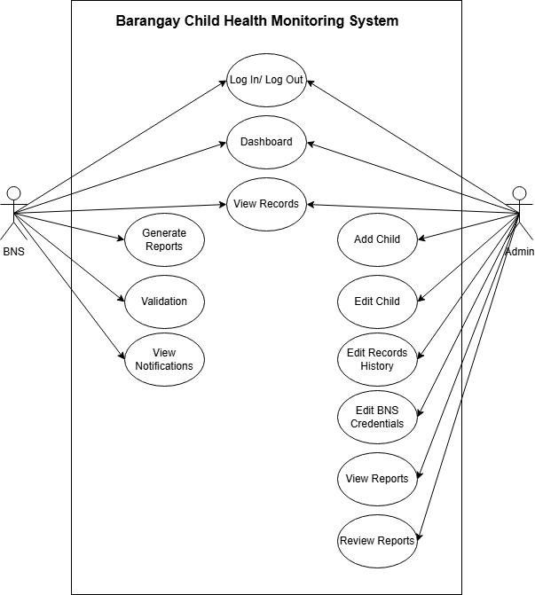

- Data Flow:
  - Input: Child info, health data
  - Process: Data Entry → Report Generation → Validation → Storage → BMI Calculation → Alerts
  - Output: Reports, Graphs, Notifications
- Architecture:
  - Client-side application with local database and optional cloud sync.
  - Backup module and admin control panel.

3.5 Database Design (Revised Diagram According to the Previous Meeting)
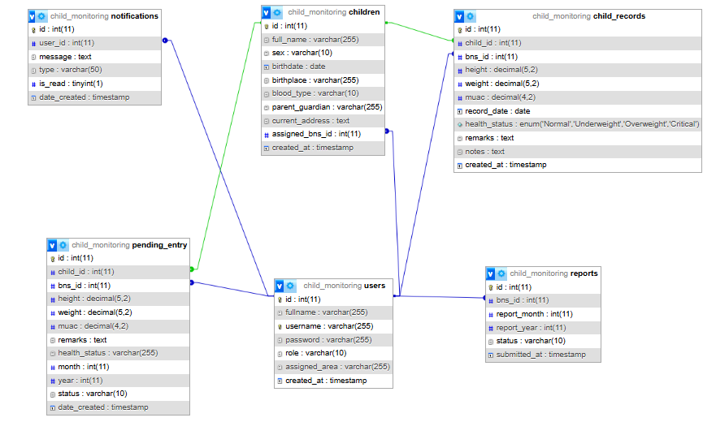

Main Tables:
• tbl_users – stores user accounts and roles (fullname, username, password, assigned area, created date).
• tbl_children – stores personal information of each child (name, birthdate, sex, address, parent/guardian).
• tbl_child_records – stores verified child health data (height, weight, MUAC, health status, record date).
• tbl_pending_entry – stores unverified or pending child measurements waiting for approval.
• tbl_notifications – stores alerts and reminders sent to users.
• tbl_reports – stores monthly and yearly reports submitted by BNS users.

Relationships:
• tbl_users → tbl_children (1 to many)
• tbl_users → tbl_reports (1 to many)
• tbl_users → tbl_notifications (1 to many)
• tbl_users → tbl_pending_entry (1 to many)
• tbl_children → tbl_child_records (1 to many)
• tbl_children → tbl_pending_entry (1 to many)

3.6 Implementation
- Development Tools:
  - Programming Language: PHP / JavaScript
  - Database: MySQL
  - Front-End: HTML, CSS, JavaScript
  - Back-End: PHP (for server-side scripting)

- Implementation Phases:
    - System Design – Finalize database structure and system architecture.
    - Development – Code modules for user management, data entry, reports, and alerts.
    - Testing – Unit testing, system testing, and user acceptance testing with barangay personnel.
    - Deployment – Install in barangay computers or local server.
    - Maintenance – Regular updates, bug fixes, and improvements.
- Security Measures:
  - Encrypted database passwords
  - Secure authentication system
  - Regular backups and role-based access
4. TESTING
Load Test results
System Context: The Barangay Child Health Monitoring System is a web-based system that records and monitors children health. Our load test simulated Child Records during peak children registration periods.

Table 1: Load Test Performance Metrics
Database Load(Children Monitored) | Average Response Time (per sec) | System Performance Observation
1,000 children monitored | Below 1 second | Excellent performance system response instantly.
10,000 children monitored | 3 seconds | Efficient and stable performance.
50,000 children monitored | 18-20 seconds | System is starting to load for a while, but the system remains stable.
100,000 children monitored | 35-40 seconds | the system Loads time is getting longer, but the system still stable and a bit of delay to load page.
170,000 children monitored | 1 minute and 5 seconds | Peak response time with a longer load time, the system is at its  functional limit, page load response delayed, to view the records it takes 1 minute and 5 seconds.

The load test of the Barangay Child Health Monitoring System demonstrates the performance of the system under increasing children monitored, through response time gradually increase, with 1000 children monitored, response was excellent at below 1 second, the response was delayed for 3 seconds to view 10,000 child monitored still the performance was stable, and 18-20 second the system starting to load the data longer but still the performance remains stable at 50,000 children monitored, and 35-40 seconds at 100,000 child monitored, at the maximum load of 170,000, response times peaked at 1 minute and 10 seconds to load the children monitored the system takes too long to response.
In order to keep the system performance remained stable, optimization efforts must focus on implementing advanced database indexing, query caching, and pagination strategies to ensure performance remains stable, confirming that the current database indexing and query design cannot support large-scale inventory operations.

Stress Test Results
System Context: The Barangay Child Health Monitoring System is a local web-based system used to record and monitor children’s health data. The stress test evaluates the system’s behavior under worst-case conditions by simultaneously increasing the database size and the number of concurrent users beyond normal operational limits. This scenario simulates peak usage periods, such as multiple barangay health workers accessing and reviewing child records at the same time on a local deployment environment.

Table 2: Stress Test Performance and Breaking Point Analysis
Database load (Children Monitored) | Concurrent User & Actions | System Response | System Performance
20,000 children monitored | 10 Users Performing:  - View Child Records | System response: >10 seconds | The system performance is degraded but remains operational.
20,000 children monitored | 15 Users Performing:  - View Child Records | System response: 13 seconds | The System remains operational but took longer to response.
30,000 Children monitored | 10 Users Performing:  - View Child Records | System response: 15 seconds | The system starts showing performance issues, UI freeze and took longer to response, but it stays responsive
30,000 Children monitored | 20 Users Performing:  - View Child Records | System response time: N/A | Breaking point reached, system becomes unresponsive.
Recovery Test (return to 10,000 Children monitored and 5 users) | 5 Users Performing:  - View Child Records | System response:  >3 seconds | System successfully recovers and returns to normal operation.

The stress test evaluated the Barangay Child Health Monitoring System under worst-case operating conditions by simultaneously increasing the number of child records in the database and the number of concurrent users accessing the system. This scenario simulates peak usage periods, such as simultaneous record reviews and reporting activities by barangay health workers on a local deployment environment.

The results show that with 20,000 child records, the system remained operational with 10 to 15 concurrent users, although response times exceeded 10 seconds, indicating degraded performance. When the database size increased to 30,000 records with 10 concurrent users, the system exhibited noticeable delays and occasional interface unresponsiveness, but core functions were still accessible. However, at 30,000 records with 20 concurrent users, the system reached its breaking point, where the web application failed to load data and became completely unresponsive.

A recovery test was performed by reducing the load to 10,000 child records and 5 concurrent users, after which the system returned to stable operation with response times of approximately 3 seconds. This confirms that the failure was caused by excessive load rather than data corruption. Overall, the stress test indicates that the system can tolerate moderate overload conditions but is limited in handling high concurrency with large data volumes. These findings highlight the need for database optimization, improved query handling, and better concurrency management to enhance system scalability and reliability.

User Acceptance Test (UAT) Plan

This User Acceptance Test (UAT) Plan outlines the procedures used to evaluate the functionality, usability, and overall performance of the Barangay Child Health Monitoring System. The purpose of this testing is to determine whether the system meets user expectations and is ready for academic submission.
Table 3:
Testing Objectives | The objectives of this User Acceptance Testing are to:  - Evaluate the correctness of system functions  - Assess the ease of use and user experience of the system  - Measure the system’s performance under normal usage conditions
Evaluation test | The system was evaluated based on the following criteria:  - Functionality – correctness and completeness of features.  - Usability – ease of navigation, clarity of interface, and user satisfaction.  - Performance – system responsiveness and stability during operation.
Testing Place | The testing will be conducted in Begong Tigbao ZDS Barangay Health Center.
Test Participant | Barangay Health Workers

Testing Criteria
Software Evaluation Sheet

Table 4: Questioner Range and Description
Range | Quantitative Discription
5 | Strongly Agree
4 | Agree
3 | Neutral
2 | Disagree
1 | Strongly Disagree

Table 5: Evaluation Criteria test result
Evaluation | 1 | 2 | 3 | 4 | 5
1.The system function according to its intended purpose. |  |  |  | 6 | 2
2. All system features work properly without errors. | 1 |  | 2 | 2 | 5
3. The system provides accurate result and information. |  |  | 1 | 4 | 3
4. The system is easy to use. |  |  | 1 | 2 | 5
5. Navigation within the system is clear and understandable. | 1 |  |  | 3 | 4
6.Instructions and labels are easy to understand. | 1 |  |  | 3 | 4
7.The system’s interface in visually. |  |  | 1 | 5 | 2
8.The layout and design are well organized. | 1 |  |  | 3 | 4
9.Text buttons and icons are easy to read and recognize. |  |  |  | 2 | 6
10.The system responds quickly to user actions. |  |  |  | 3 | 5
11.The system performs well without lag or crashes. | 1 |  | 2 | 2 | 3
12.The system is reliable during use. |  |  |  | 6 | 2
13.I feel data is safe and secure when using the system. |  |  |  | 4 | 4
14.I am satisfied with the overall performance of the system. | 1 |  |  | 2 | 5
15.I would recommend this system to other users. |  |  |  | 2 | 6

Summary of evaluation Criteria test result
The results of the evaluation conducted, the Barangay Child Health Monitoring System in terms of Functionality, Usability, and overall Performance. The responses gathered from Barangay Health Workers indicate that most respondents selected “Agree” and “Strongly Agree” across the majority of the evaluation items.
In terms of functionality, respondents agreed that the system performs according to its intended purpose, with system features working properly and producing accurate results and information. This suggests that the core functions of the system effectively support child health monitoring tasks.
For usability, the evaluation results show positive feedback regarding ease of use, clarity of navigation, and understandability of instructions, labels, and interface elements. The system layout, design, text, buttons, and icons were generally perceived as clear and well organized, allowing users to interact with the system with minimal difficulty.
Regarding performance and reliability, most respondents agreed that the system responds quickly to user actions, performs well without frequent lag or crashes, and remains reliable during use. Additionally, respondents expressed confidence in the system’s data security and overall performance.

Conclusion of the Evaluation
The results of the evaluation criteria test indicate that the Barangay Child Health Monitoring System is functional, user-friendly, and reliable under normal operating conditions. The positive responses from the Barangay Health Workers demonstrate that the system meets its intended objectives and is suitable for supporting child health data recording and monitoring at the barangay level.
Overall, the system achieved satisfactory results in functionality, usability, and performance, suggesting that it is acceptable for academic submission and demonstration. Although the evaluation was conducted using representative users, the findings provide sufficient evidence that the system is capable of meeting user requirements. Further improvements may be implemented in future versions to enhance system performance and scalability.

✅ Reference:
Thaventhiran, A., et al. (2024). Digital health solutions for child growth monitoring and early detection of undernutrition. PubMed Central. Retrieved from https://pmc.ncbi.nlm.nih.gov/articles/PMC10759636

